***NAME: SHERALI***

***SECTION: BSCS 1A***

***PROGRAMMING FUNDAMENTAL LAB***

***LAB 10 LIST TASK***

***QUESTION1:***

a=[1,3,5]

b=[2,4,6]

c=a+b

print(c)

list_1=[7,8,9]

c+=(list_1)

print(c)

print(c[0:3])

print(b[-1])

length=len(a)

print(length)

sum=0

for i in c:

sum+=i

print(sum)

average=sum/len(c)

print("The average is =",average)

minimum=1

for i in c:

if i<minimum:

minimum=i

print("The minimum is=",minimum)

fourth_element=c[0:3]+[42]+c[3:9]

print("Adding Fourth_element in list c =",fourth_element)

***Minimum:***

minimum=1

for i in c:

if i<minimum:

minimum=i

print("The minimum is=",minimum)

fourth_element=c[0:3]+[42]+c[3:9]

print("Adding Fourth_element in list c =",fourth_element)

***OUTPUT:***

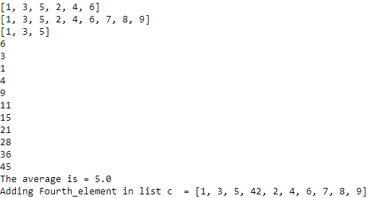

***QUESTION 2:***

def same_number(list_1,list_2):

for x in list_1:

for y in list_2:

if x==y:

return True

return False

same_number([1,2,3],[4,5,2])

***OUTPUT:***



***QUESTION 3:***

***NOT GRADED TASK:***

def unique_element(l):

x=[]

for a in l:

if a not in x:

x.append(a)

return x

print(unique_element([33,55,66,77,77]))

***OUTPUT:***



***QUESTION4:***

x=[0,3,2,4,5]

y=[]

while x:

minimum=x[0]

for element in x:

if element>minimum:

minimum=element

x.remove(minimum)

y.append(minimum)

print(y)

***OUTPUT:***

